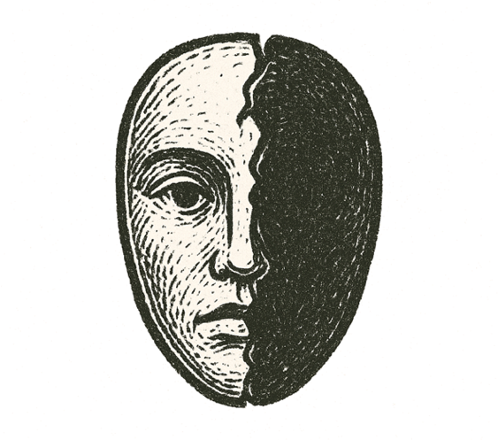
The room was quiet. Lamplight pooled on faded carpet, shadows clinging to corners. A single bed sat askew, sheets rumpled like a storm had passed.
Breath came shallow in the heavy air. A glass on the nightstand caught the light, trembling slightly with each heartbeat.
A mirror reflected a hollow face — eyes distant, pupils dark, thoughts lost somewhere cold. Fingers toyed with objects on the dresser, each motion deliberate, detached.
Outside the door, laughter drifted down the hallway, oblivious to the silence inside. Inside, morality slipped from its moorings.
The mind that once mapped right from wrong twisted on itself, each thought feeding darker impulses.
No monster waited under the bed. The monster was already here, wearing a human face.

How fragile is the line between thought and horror?

